**ENGR 122 Homework 7**

**NOTE:** Use engineering format for problems 1 through 4. Use non-engineering format for problem 5. This is an individual assignment.

1. A 145lb engineering student who is standing on beam EDF pulls vertically downward on a rope attached to beam ABC. A second rope is attached vertically between points C and D. If the alligator weighs 985lbs and the center of gravity of the alligator (the place where the weight can be lumped) is 3ft to the left of the pinned connection at point B, then what is the pulling force of the student? 36.63lbf

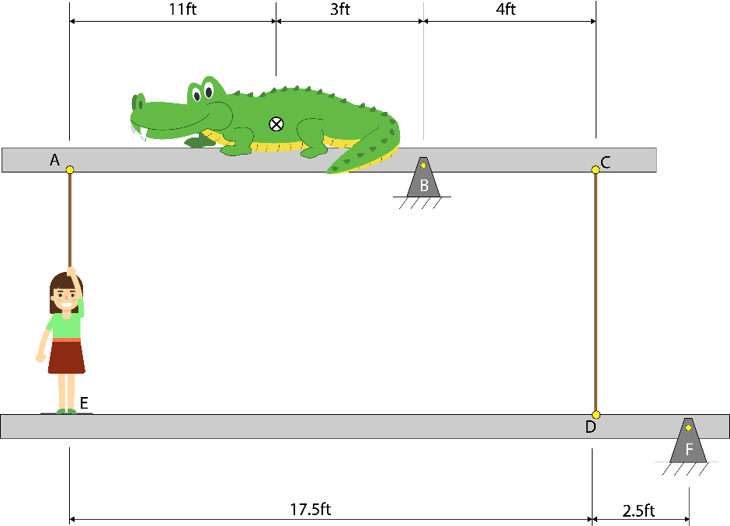**Tips:**

* + - * Neglect the weight of the beams.

* + - * Draw 2 FBDs, one for each beam.

* + - * Initially treat this as two separate beam problems, and then combine the resulting equations to solve for the rope tension at A.

* + - * The force in the rope is always in tension (can’t push with a rope).

**Given:**  Wstudent = 145 lbs

Wgator = 985 lbs

Xgator = 3 ft

Xstudent = 20 ft

XD = 2.5 ft

XC = 4 ft

XA = 14 ft



**Request:**  FA in lbf

**Solution:**



$$\sum{M_{EDF}=-145 lbs*20 ft+2.5 {ft*F}_{C-D}+F_{A}*20ft=0}$$

$$2.5 {ft*F}_{C-D}=2900 lb*ft-F_{A}*20ft$$

$$F_{C-D}=1160 lbs-F_{A}*8ft$$

$$\sum{M_{ABC}=-F_{A}*14ft-985 lbs*3 ft+4 {ft*F}_{C-D}+=0}$$

$$4ft*F_{C-D}=F_{A}*14ft+2955lb*ft$$

$$F_{C-D}=F_{A}*3.5ft+738.75lbs$$

$$F_{A}*3.5ft+738.75lbs=1160 lbs-F_{A}*8ft$$

$$F_{A}*11.5ft=421.25 lbs$$

$$F_{A}=36.6304 lbf$$

1. A 150kg mass is lifted by a pulley with a diameter of 0.75m. The motor and gear train have a system efficiency of 76%. If the 150kg mass is lifted upward 2.75m in one second, what is the DC power that must be delivered to the motor? 5.32kW

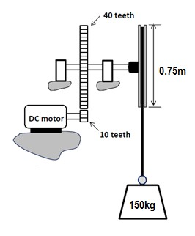

**Given:** W = 150 kg

g = 9.8086 m/s2

h = 2.75 m

ɲ = 76% = 0.76

t = 1 sec

**Request:** Wattage (V*I) in kW

**Solution:**

$$ɲ=\frac{W*h}{V*I*t}$$

$$V*I=\frac{W*h}{ɲ*t}$$

$$V*I=\frac{\left(150 kg*9.8086 \frac{m}{s^{2}}\right)*2.75 m}{0.76*1 sec}=5323.7467 w=5.3237467 kW$$

1. The DC motor spins at 4200 RPM. Find the
   * 1. Rate of rotation (RPM) of the gear with 57 teeth. 200.96 RPM
     2. Velocity (m/s) that the weight moves as it is being lifted by the gearmotor. 1.34m/s
     3. Current provided to the motor if the voltage supplied is 24V and its efficiency is 35%. 2.39A

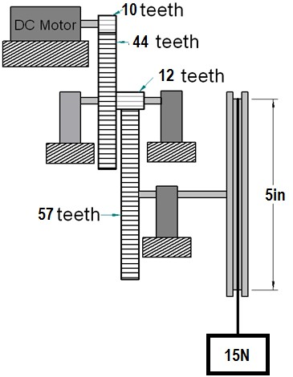

1. **Given:** RPM = 4200 rev/min

T1 = 10 teeth

T2 = 44 teeth

T3 = 12 teeth

T4 = 57 teeth

**Request:** RPM of T4 in rev/min

**Solution:**

$$\frac{W_{4}}{W_{1}}=\frac{T_{1}}{T_{2}}*\frac{T_{3}}{T_{4}}$$

$$W_{4}=4200 rpm* \frac{10}{44}*\frac{12}{57}=200.95694 rpm$$

1. **Given:** RPMout = 200.95694 rpm

Diameter = 5 in

0.0254 m/in

**Request:** Vweight in m/s

**Solution:**

$$5 in*0.0254 \frac{m}{in}=0.127 m$$

$$V_{weight}=200.95694\frac{rev}{min}*\frac{π*0.127 m}{1 rev}=80.179 \frac{m}{s}$$

There is something wrong with the answer given above. For that answer to be true, the radius of the pulley has to be very small. Using the equation, the radius would have to be

$$\frac{1.34\frac{m}{s}}{200.95694\frac{rev}{min}*π}=0.00212252 m*\frac{1 in}{0.0254 m}=0.08356 inches$$

Which is not the radius given.

1. **Given:** The above

V = 24V

ɲ = 35% = 0.35

v = h/t = 1.34 m/s

W = 15N

**Request:** I in amps

**Solution:**

$$ɲ=\frac{W*h}{V*I*t}=\frac{W}{V*I}*v$$

$$I=\frac{W}{V*ɲ}*v=\frac{15N}{24V*0.35}*1.34\frac{m}{s}=2.39A$$

1. Recall the data that you collected during the last class.
   1. Complete the table below.
   2. Show hand calculations for one data point, where the calculations include all relevant units.
   3. Provide a plot of Efficiency versus Voltage. Be sure to use proper plotting format. Include the appropriate trendline for your data with the equation and r2 value displayed on the plot.
   4. Plot Lift Speed (cm/s) versus Voltage. Be sure to use proper plotting format. Include the appropriate trendline for your data with the equation and r2 value displayed on the plot.

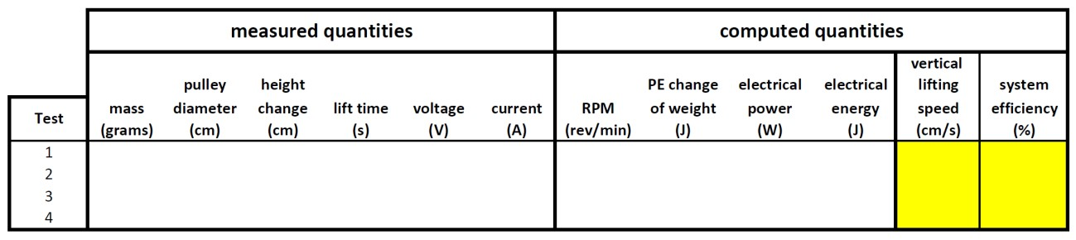

1. Review the project ideas in your Idea Wallet. Choose your top two ideas. Write a few sentences about each idea, why you like it, and why you think your team should do that project. You will use this as a basis for discussion with your group when you start to narrow down the project ideas.

The top two ideas in my Idea Wallet are the boxing gloves that measure punching speed and force, and the device for detecting skin undertone.

I like the boxing glove idea the most because it is very simple to program, the materials would be easy to obtain, and it has a real potential use for training. I feel like we could pull off this project well considering that the idea is quite straightforward and simple. The only limiting factor is the technology we are able to implement through the Arduino.

The undertone picker is in my opinion a cool idea because it’s something that I would use personally, and it would primarily use technology that we are already familiar with from 120: photoresistors. Thus, the learning curve required for building this thing would be low in terms of the hardware.